|  |  |  |  |
| --- | --- | --- | --- |
| **Mobile Applications and Web Development -IS4904(Practical)** | | | |
| **Student Name:** | **Student ID:** | | **Section:** |
| **Assignment (Exploring the Health Informatics Stack)** | | | |
| **Date: 5th March 2024** | | **Max Points:** | |

**Submission Guidelines:**

Submit the essay and Dart program files via the designated submission platform.

Ensure code is well-commented and follows Dart style conventions.

**Question** 1: Introduction to Null Safety in Dart

**Objective**:

To reinforce understanding of the concept of null safety in Dart and its significance in writing reliable code.

**Tasks**:

1. Write a short essay explaining the importance of null safety in Dart programming(two lines max).

null is for indicating the absence of a value , It help prevent error during run and compile time , it makes the code more safe and easy to read by others .

1. Create a Dart program that demonstrates the difference between nullable and non-nullable variables. Use both nullable and non-nullable variables in your program and explain how null safety affects their usage.

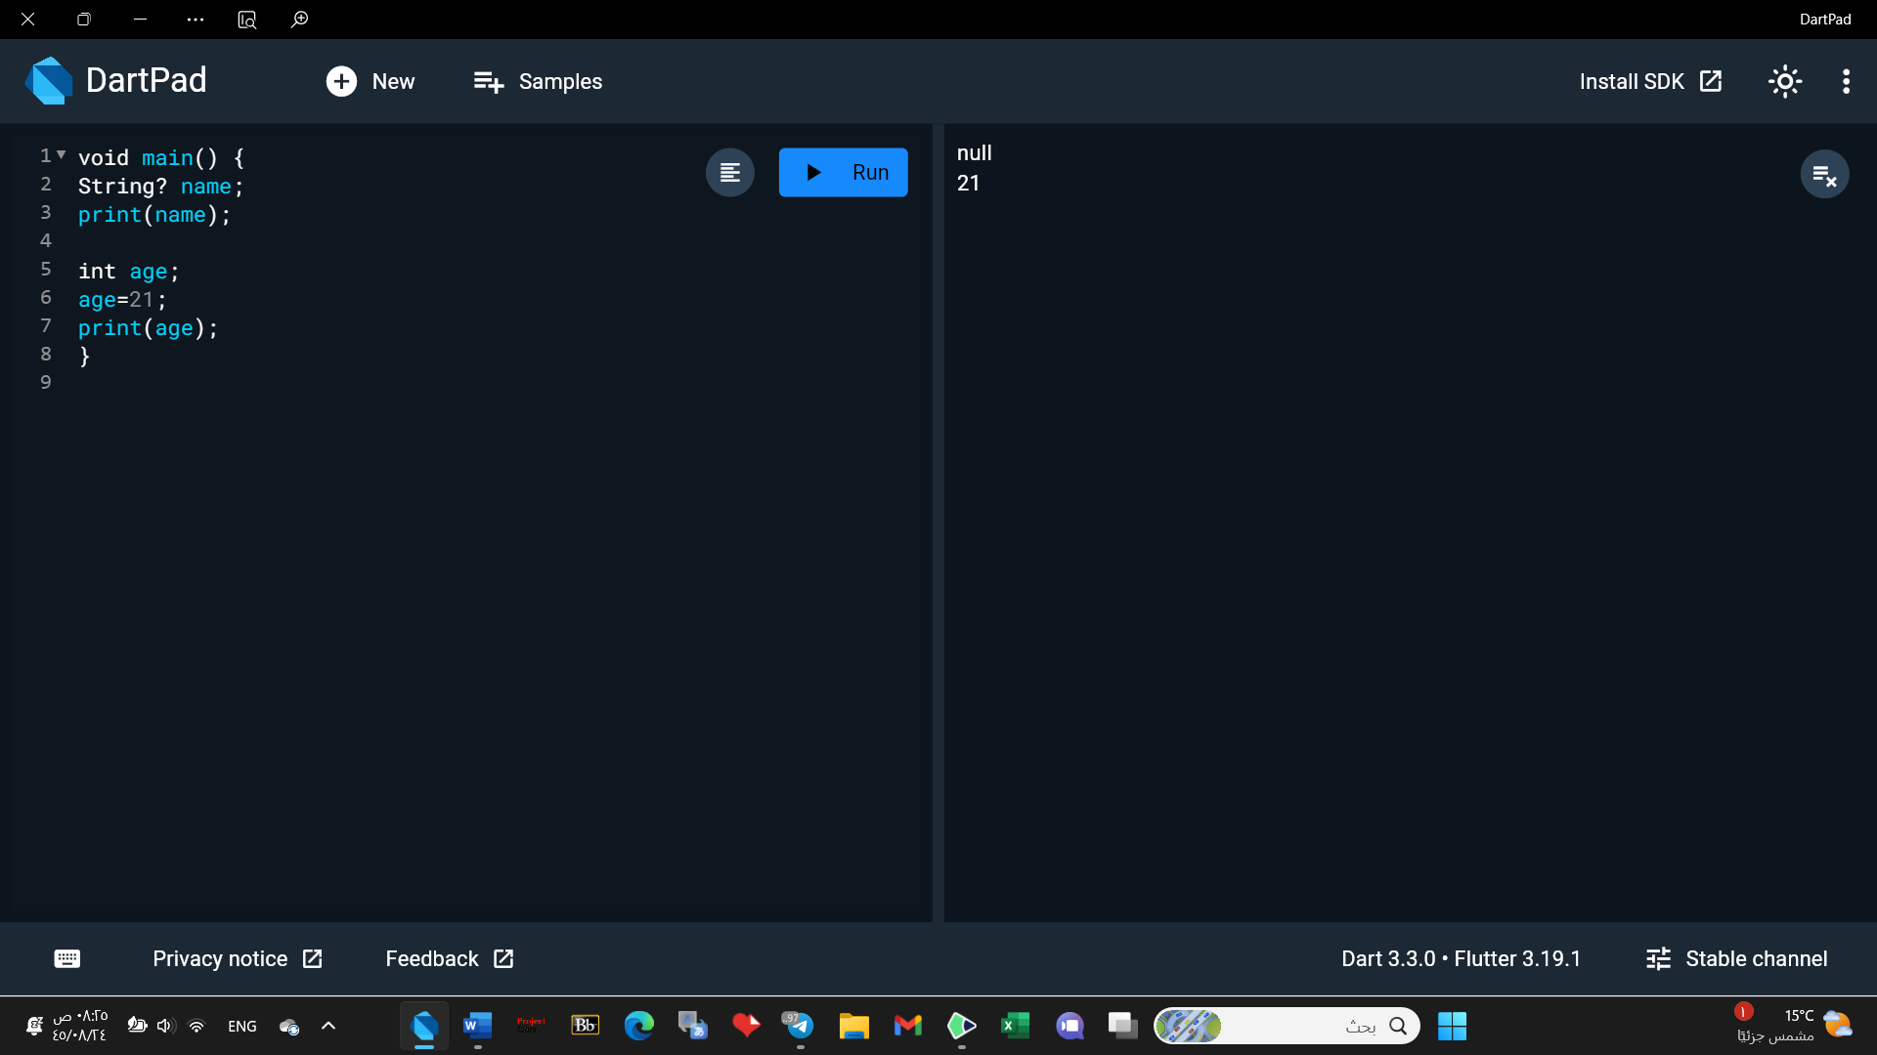

At first line name variable has no value and when we print it , it will be null because we use nullable variable , the second line it dose not allow for null value because it is a non nullable variable

**Question** 2: Handling Null Values in Dart

**Objective**:

To practice working with nullable types and null-aware operators in Dart to effectively handle null values.

**Tasks**:

1. Write a Dart program that demonstrates the use of null-aware operators (??, ?., ??=) to handle null values. Include examples of each operator in your program and explain their purpose.

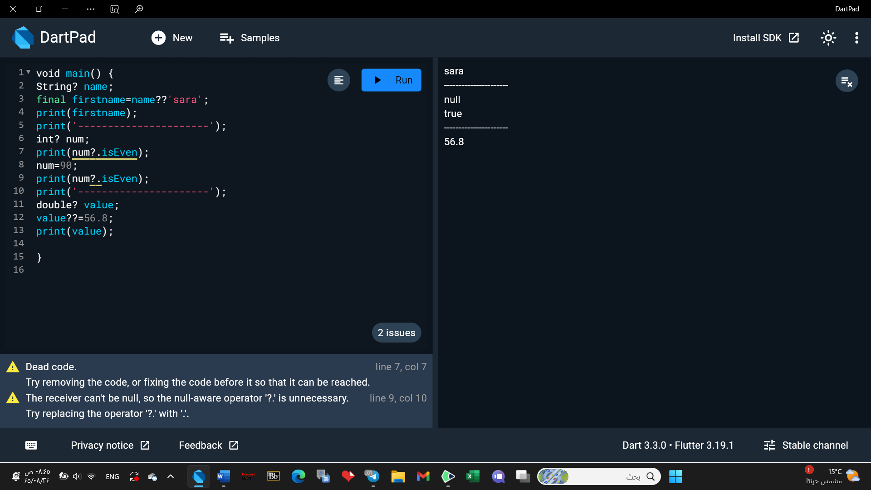

?? / If the value on the left is null, then use the value on the right.

?. / returns null if the left-hand side is null. Otherwise, it returns the property on the right-hand side.

??= / it perform the same job as ?? but with little difference and shorter , when the variable dose not have a value it assigned to the value on the right hand side by default .

1. Write a Dart program and develop a function that takes a nullable integer parameter and returns a non-nullable integer. Handle null values appropriately within the function and explain your approach.

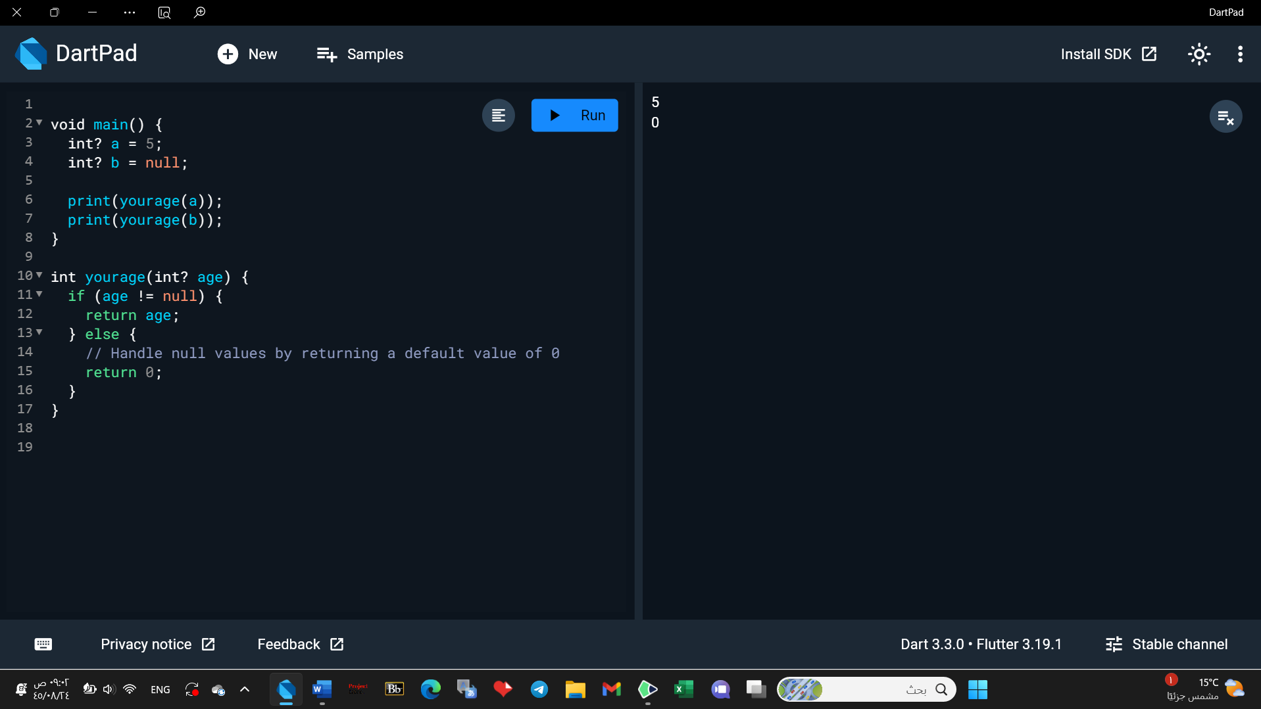

If the value isn't null it return the value , if it's null it return 0.

1. Create a Dart program that reads user input for a person's age and prints a customized message based on the input. Ensure the program handles null values and invalid input gracefully.

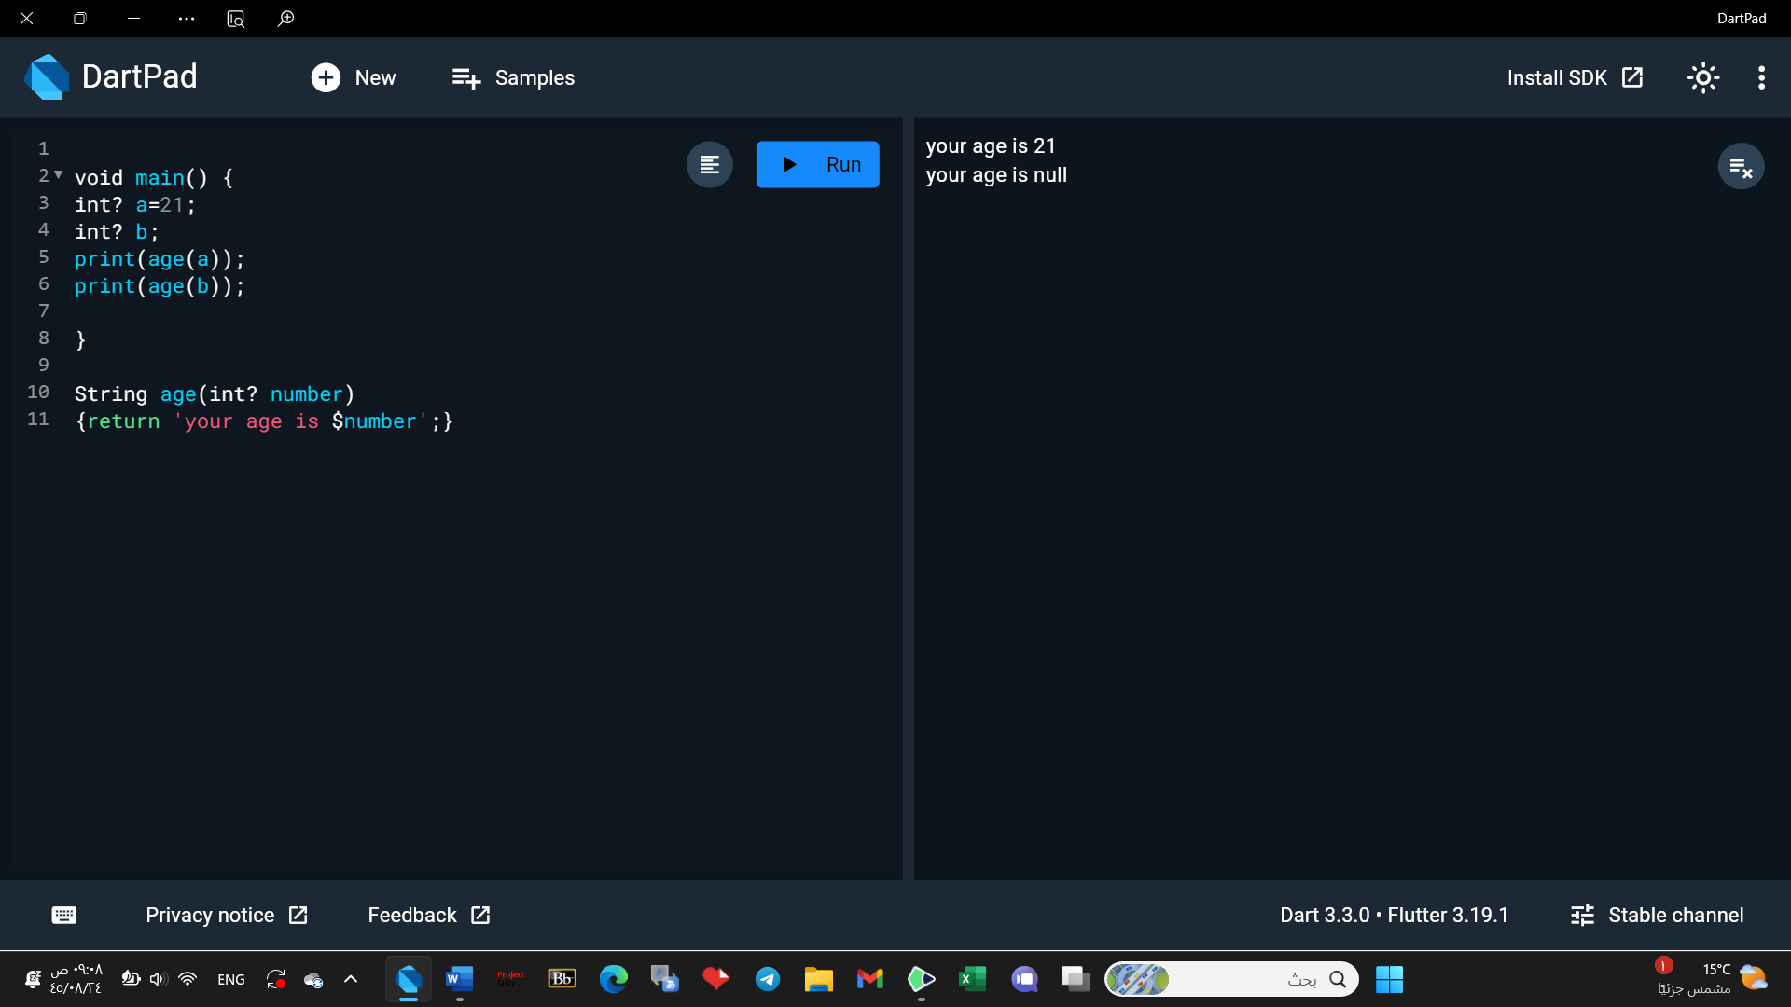

**Question** 3: Handling Null Values in Dart

**Objective**:

To delve deeper into advanced techniques for handling null values in Dart and practice implementing null-safe code patterns.

**Tasks**:

1. Write a Dart program that utilizes the **late** keyword and null assertion operator (!) to handle delayed initialization of non-nullable variables.

